# A SOLAR POWERED SMART AQUAPONICS SYSTEM

**By**

**Muhammad Usama 00000123193**

**Hassaan Abdullah 00000120044**



# A Project report submitted in partial fulfillment of the requirement for the degree of Bachelors in Electrical (Electronics) Engineering

**Department of Electrical Engineering**

# School of Electrical Engineering & Computer Science

# National University of Sciences & Technology

# Islamabad, Pakistan

# 2019

**CERTIFICATE**

It is certified that the contents and form of thesis entitled **“A SOLAR POWERED SMART AQUAPONICS SYSTEM”** submitted by **Muhammad Usama (2019-NUST-SEECS-BEE7) and Hassaan Abdullah (2019-NUST-SEECS-BEE7)** have been found satisfactory for the requirement of the degree.

**Advisor: ______________________________**

**(Dr. Nosherwan Shoaib)**

**Co-Advisor: ______________________________**

**(Mr. Ahsan Azhar)**

**DEDICATION**

To Allah the Almighty

&

To my Parents and Faculty

**ACKNOWLEDGEMENTS**

I am deeply thankful to my advisor and Co-Advisor, Dr. Nosherwan Shoaib, and Mr. Ahsan Azhar for helping me throughout the course in accomplishing my final project. Their guidance, support and motivation enabled me in achieving the objectives of the project.

I am also thankful to my committee members, Dr. Ahmad Salman, Dr. Hasan Aqeel Khan and others, for their valuable feedback. Apart from them I am also thankful to Mr. Kalim Ullah for his help, at the crucial stages of the project. Finally, I am extremely thankful to Mr. Ahmad Shafqat for guiding me through emails and sparing her valuable time for me.

**TABLE OF CONTENTS**

ABSTRACT 1

1 Introduction 2

1.1 Importance 2

1.2 Project Goal 3

1.3 Report Organization 4

2 Literature Review 5

2.1 Key Concepts 5

Comparison of Land, Water, and Energy Requirements of Lettuce Grown Using Hydroponic vs. Conventional Agricultural Methods 5

Design of a Smart Monitoring and Control System for Aquaponics Based on OpenWrt 6

The Production of Catfish and Vegetables in an Aquaponic System 6

Design of Aquaponics Water Monitoring System Using Arduino Microcontroller 6

How to Hydroponics, Fourth Edition [Keith Roberto] 6

2.2 Current Industries 7

2.3 Future of Soilless Farming Trends 8

2.4 Problem with Aquaponics 9

3 Functionality and Design 10

3.1 Methods used to carry out the proposed solution 10

3.1.1 System Block Diagram: 10

3.1.2 PVC Structure: 11

3.1.3 Sensors: 15

3.1.4 Microcontroller Unit 17

3.1.5 Central Device: 19

3.1.6 Solar Panel: 20

3.2 Justification of method used 21

3.3 Justification of design tools 23

3.4 Basic theoretical information about each component 24

3.4.1 BLE Communication: 24

3.4.2 GATT: 24

3.4.3 Connected Network Topology: 24

3.4.4 GATT Transactions: 25

3.4.5 Curve Fitting (Support Vector Regression): 27

3.4.6 Support Vector Machines and Support Vector Regression 27

3.4.7 Maximum Power Point Tracking (MPPT) 32

4 Implementation and Results 34

4.1 Implementation 34

4.2 Results 36

5 Conclusion and Recommendation 38

5.1 Conclusion 38

5.2 Recommendation 39

References 40

Journals 40

Books 40

Internet 41

**LIST OF FIGURES**

Figure 1.1 Aquaponics Cycle 1

Figure 1.2 Kashmir Highway 2002 vs 2018 2

Figure 1.3 Faisal Masjid 2002 vs 2018 3

Figure 2.1 World Compound Annual Growth Rate 8

Figure 2.2 Global Market Share 8

Figure 2.3 Agricultural Land Use 9

Figure 3.1.1 System Block Diagram 10

Figure 3.1.2 Structure Top View 11

Figure 3.1.3 Structure Side View 12

Figure 3.1.4 Functional Structure 12

Figures 3.1.5 Crops Grown 13

Figure 3.1.6 Aquarium 13

Figure 3.1.7 A&B Sensor 3D Model 15

Figure 3.1.8 Sensor Mesh 15

Figure 3.1.9 Sensors 16

Figure 3.1.10 Readbear BLE Nano v2 17

Figure 3.1.11 Data Flow Block Diagram 18

Figure 3.1.12 A&B Server Block Diagram & Raspberry Pi 3B+ 19

Figure 3.1.13 Curve Fitting Block Diagram 19

Figure 3.2.1 NFT example 22

Figure 3.4.1 Topology of BLE Communication 25

Figure 3.4.2 GATT Transaction 25

Figure 3.4.3 Illustrations of Profiles, services and characteristics 26

Figure 3.4.4 Linear curve fitting on random data points 27

Figure 3.4.5 Use of hyper plane by SVM 27

Figure 3.4.6 A problem in R2 is projected to R3 to get a linear decision boundary 28

Figure 3.4.7 Red Lines are boundary line while Blue line is hyper plane 29

Figure 3.4.8 Linear SVR explanation 30

Figure 3.4.9 Converting non-linear regression to linear regression 31

Figure 3.4.10 Maximum Power Point 32

Figure 3.4.11 MPPT Algorithms during start-up 33

Figure 3.4.12 MPPT Algorithms at steady state 33

Figure 4.1 Results in Raspberry Pi 36

Figure 4.2 SVM Results 37

**LIST OF TABLES**

Table 2.1 Notable Companies 7

Table 3.1 Sensors and Their Uses 17

Table 3.4.1 Data stored in ATT 24

Table 3.4.2 Some basic terms used above and later on in this discussion 29

# ABSTRACT

The project combines aquaculture –fish farming, left- and hydroponics –growing plants in a soilless medium, right- in an aim to provide an alternative to food production on an industrial, as well as, private scale. The project has been designed by considering urban areas with low land and over-population. Once fully functional, the project will require minimal human interference during the cultivation process with an increase in food output compared to traditional farming technique.

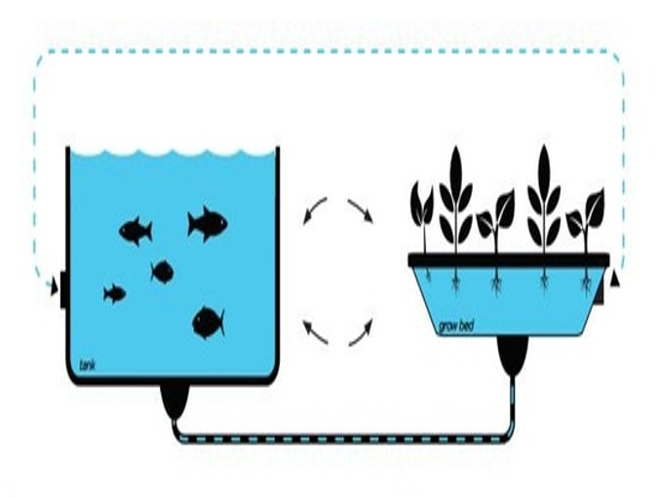

Figure 1.1 Aquaponics Cycle

The final product will be organic – free from contaminants such as pesticides – and cheaper than traditionally grown crops. The system will also provide user with useful suggestions regarding the next cultivation process and the feasibility of current crop.

# *Chapter 1*

# Introduction

## 1.1 Importance

The increased population and urbanization of farm lands in Pakistan is a concern of immediate attention because in the near future it can lead to possible food shortages in terms of local food production. Farms have been pushed far from cities; this increased distance only adds to heavy transportation costs in terms of paper money and environmental impact. The ratio of water lost versus that consumed by the crops in traditional farming techniques is alarming, especially when considering water shortages in congested cities such as Karachi. Not to mention the use of poisonous pesticides and insecticides on crops have negative health impacts on the consumers. And finally, the increased deforestation leading to global warming due to increased greenhouse gasses, such as carbon dioxide, which is already a global concern.

Islamabad is another city in which the effects of urbanization can be seen – below.

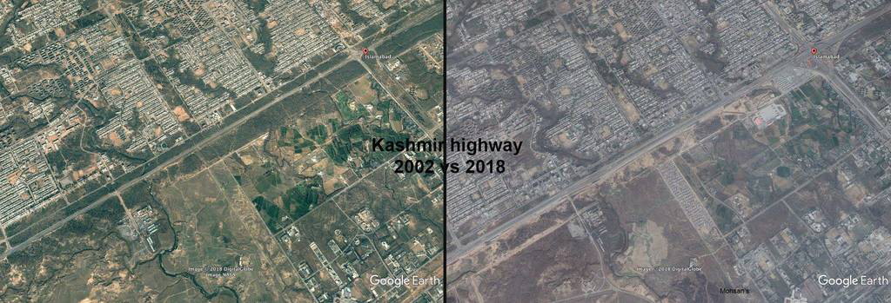

Figure 1.2 Kashmir Highway 2002 vs 2018

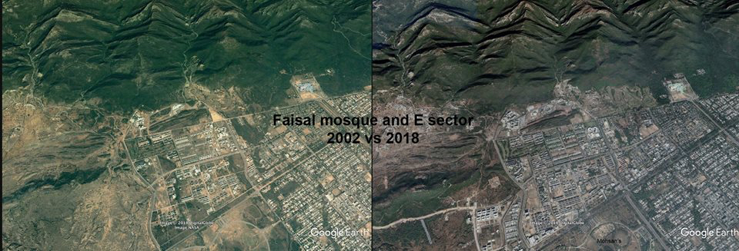

Figure 1.3 Faisal Masjid 2002 vs 2018

The aquaponics technique is being majorly used in China, USA and Europe. Unfortunately, Pakistan lacks far behind them as we have bare minimal use of this technique in the country. Aquaponics is, both, economical and environment friendly, and once widely used, will eliminate the need for Pakistan to import food from other countries.

The above mentioned problems can be seen as a potential entry wedge of Aquaponics into our domestic as well as international markets.

## 1.2 Project Goal

The goal of the project was to:

* To design efficient systems in terms of water usage, and a higher crop yield.
* To design a sensor mesh, generic in nature; so that it may be used in any other related art.
* To develop power efficient and eco-friendly prototypes.
* To make the system solar powered.
* To increase awareness relating to the benefits of aquaponics.
* To install portable, lightweight and sturdy systems; compatible for use in urban environment.

## 1.3 Report Organization

The report is organized into four chapters.

***Chapter 1*** *introduction.*

***Chapter 2*** *explains current and future trends of soil-less farming techniques.*

***Chapter 3*** *gives insight into implementation of Aquaponics and discusses various industries that use .It also gives a detailed overview of the basic concepts and the building blocks involved in Aquaponics.*

***Chapter 4*** *discusses the testing of the Aquaponics system. It involves different flowcharts, structure diagrams and plots to describe the working of techniques used.*

# *Chapter 2*

# Literature Review

## 2.1 Key Concepts

Aquaponics is a technique made of two separate farming techniques, namely hydroponics and aquaculture. Aquaponics uses about 90% less water than traditional farming, provides more crop yield per unit area, and does not require the use of poisonous herbicides and pesticides. Hence the produce from aquaponics is organic.

Since the technique can be applied with different types of systems, it is possible to monitor and control it. Making automation a possible solution. Which can provide with organic products grown with optimum conditions.

For the monitoring of the system; pH, Electrical Conductivity and temperature are the main variables that need to be checked. Based on these it can be decided which crops can be grown.

### Comparison of Land, Water, and Energy Requirements of Lettuce Grown Using Hydroponic vs. Conventional Agricultural Methods

Hydroponics is more efficient compared to traditional land based agricultural methods. In the case of lettuce, hydroponics offered 11 ± 1.7 times higher yields per area and saved up to 95% of water (20 ± 3.8 L/kg/y of hydroponics vs. 250 ± 25 L/kg/y of traditional land based)– mainly lost through evaporation, if not absorbed. The down side is that it required a tremendous amount of energy (90,000 ± 11,000 kJ/kg/y) compared to the 1100 ± 75 kJ/kg/y of traditional land based.

The energy consumption is mainly to keep the water circulating, and in the case of indoor hydroponics, to keep the growth LED lights on. This problem is countered by us by integrating solar energy in Cropotronics.

### Design of a Smart Monitoring and Control System for Aquaponics Based on OpenWrt

The paper deals with collecting data from the aquaponics system and transferring wirelessly through the server. The user can access this data through an application and from there decide which system to turn on or off. This signal is then transferred back to the server which then sends the signal to the actuators.

### The Production of Catfish and Vegetables in an Aquaponic System

A total of fifteen aquaponic sets were installed in an aquaculture setting at Kuala Sungai Baru, Perlis, Malaysia. Over the period of 60 days, 2 batches of 3 different vegetables were grown. Catfish were not changed during the cycles. The research recommended the use of catfish for aquaponics mainly due to their tendency to survive in low oxygen environments.

### Design of Aquaponics Water Monitoring System Using Arduino Microcontroller

Arduino was used to design a complete aquaponics system. pH, temperature and water sensors were used and the data collected. If the pH was found out of range, it was automatically brought to the desired value. If any value was found to be out of range of the desired value, a message was sent automatically through GSM.

### How to Hydroponics, Fourth Edition [Keith Roberto]

The book explained different steps of designing a hydroponics system. It includes different models you can use. Different growing materials that can be used to grow seedlings, the type of growing environment plants require. It even includes data on multiple crops and the pH, temperature etc. they require for optimized growth.

## 2.2 Current Industries

The following companies are working with hydroponics/aquaponics. However they fail to provide the complete functionality of this project.

|  |  |  |  |  |  |
| --- | --- | --- | --- | --- | --- |
| Table 2.1 Notable Companies | | | | | |
| **Name** | **Technique** | **Country/ Region** | **Product Type** | **Price** | **Remarks** |
| **GrowUp Urban Farms** | Hydroponics | UK | Crops | - | Local produce |
| **Tailor Made Fish Farms** | Aquaculture, Hydroponics | Australia | Crops and Fish | - | Local produce |
| **Kakovitch Industries** | Aquaponics | USA | Designs and builds Custom Systems | - | Mostly for commercial farms |
| **AquaSprouts** | Aquaponics | USA  May deliver in Pakistan. | AquaSprouts Garden. | $179.95  *Bundle (+LEDs etc):$260* | Small, decorative system. Can fit on a table. |
| **Back to the Roots** | Aquaponics | Only USA | Water Garden. | $ 99.99 | Small, decorative system. Can fit on a table. |
| **The Blue Green Box** | Aquaponics | Only USA | System for plants and pumps. | $ 75, $ 120, $ 300 | Aquarium and fish Not included. |
| **Osmo Systems** | Water monitoring sensor. | USA | Sensor system.  (includes 5 sensors) | $550+ | DO sensors included for additional price. |

The mentioned companies all have differences and or are lacking in something compared to our project.

GrowUp Urban Farms, Tailor Made Fish Farms and Kakovitch Industries are all commercial scale farms. They do not provide systems for the end user.

AquaSprouts, Back to the Roots and the Blue Green Box, though are indoor aquaponics systems, they are more for indoor decoration than sustainable food growth. They provide no monitoring of the system. And so cannot be considered for home farming.

Osmo Systems, although their product contains pH, electrical conductivity and temperature, as well as an option for Dissolved Oxygen sensor; it does not have any variant with which humidity and light sensors can be integrated.

## 2.3 Future of Soilless Farming Trends

Soilless farming techniques are majorly used in developed countries, yet its share has continued to increase in the past few years. By the year 2020, hydroponics is predicted to account for about 6% of the Compound Annual Growth Rate (i.e. the total food production) of the entire world. While its Global market share is expected to increase to about 13 billion USD.

Figure 2.1 World Compound Annual Growth Rate

Figure 2.2 Global Market Share

Shrinking of agricultural land is already an increasing problem of the world -as shown below. This shortage is either due to de-fertilization of soil, as a result of heavy agricultural use in the past, or urbanization. This shortage means the word will need to find a suitable alternative for crop productions. The economical alternative in urbanized areas for agriculture, are hydroponics and aquaponics, whose share in CAGR, if increased, can easily account for the food shortage.

Figure 2.3 Agricultural Land Use

## 2.4 Problem with Aquaponics

Aquaponics requires continuous care and management, which is difficult for the people, because of lack of exposure with the technique. Hence the problem at hand is to make the monitoring automated, in an effort assist the novice farmers in growing produce efficiently, and with minimum loss of crops and fish.

Another problem is to make the running cost of system to be minimum to attract the masses. Hence the system designed is light-weight –made of PVCs–, scalable –multiple systems can work together or their size increased –, and compensates its energy requirements through the use of Solar Energy.

# 

# *Chapter 3*

# Functionality and Design

In this chapter we will see,

1. Methodology and Design Tools
2. Justification of methodology
3. Justification of design tools
4. Basic theoretical information about each component

## 3.1 Methods used to carry out the proposed solution

### 3.1.1 System Block Diagram:

The proposed solution to the problems mentioned above was to provide organic food to the masses living in through aquaponics, make the system urban compatible (small, smart and sturdy) and provide smart monitoring of the system.

The block diagram below describes the functionality of the system and interaction of different modules to get the task done.

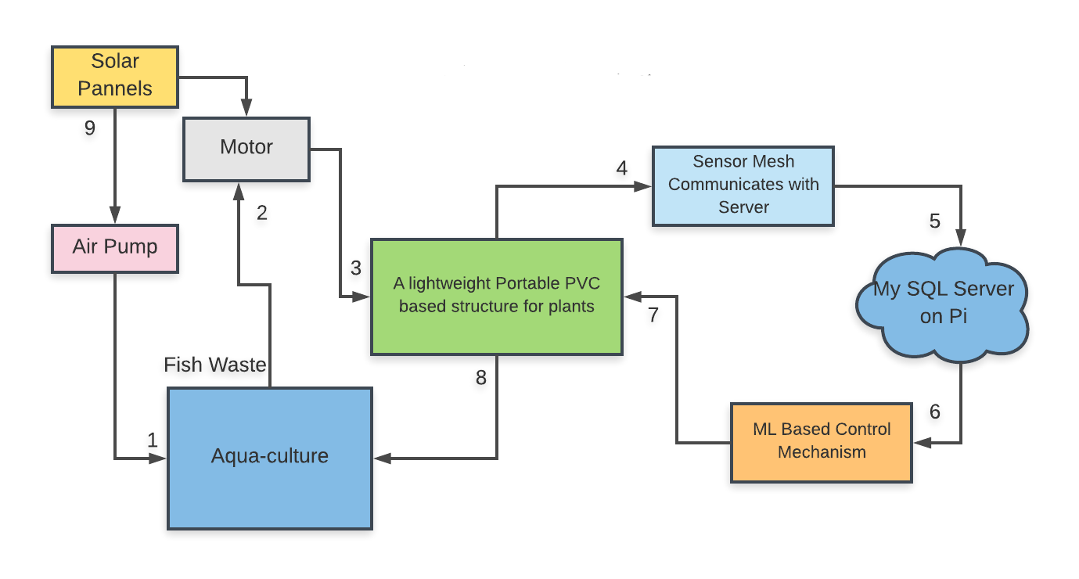

Figure 3.1.1 System Block Diagram

The block diagram, depicts the proposed system. Starting from aqua-culture (1), where fishes are fed, and their waste is deposited at bottom of the tank. The waste water from the aqua-culture is pumped out using a motor (2).

The water reaches plants (3), is checked for its pH, Electrical Conductivity, Total Dissolved Solids and temperature readings. This is done at (4) using the sensor mesh, which communicates with the main server. The main server (5) collects the data from the mesh, and runs it through the Machine Learning algorithm (6) for monitoring purposes and provide valuable feedback to the user about the feasibility of the current crop in the given conditions.

The water travels through (7), where plants are grown inside a PVC structure. There ammonia in the water is reduced to nitrates, absorbed by the plants. The purified water is fed back to the aquaculture, as it is now harmless to the fish.

### 3.1.2 PVC Structure:

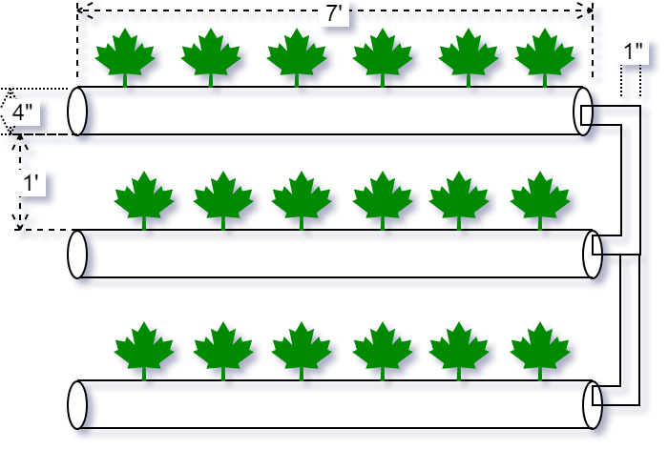

Figure 3.1.2 Structure Top View

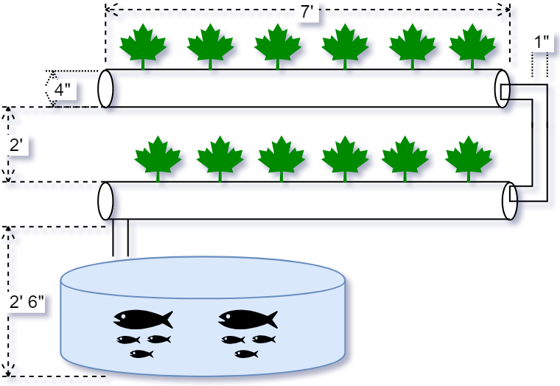

Figure 3.1.3 Structure Side View

The top and side views show the dimensions of the final structure constructed. The system has 2 layers with 3 rows each. Each row can have up to 7 net-pots to hold the crops, totaling to 42 plants each. The layers are high enough for a person to place or remove the net-pots easily, leaving enough room for a small fish tank beneath.

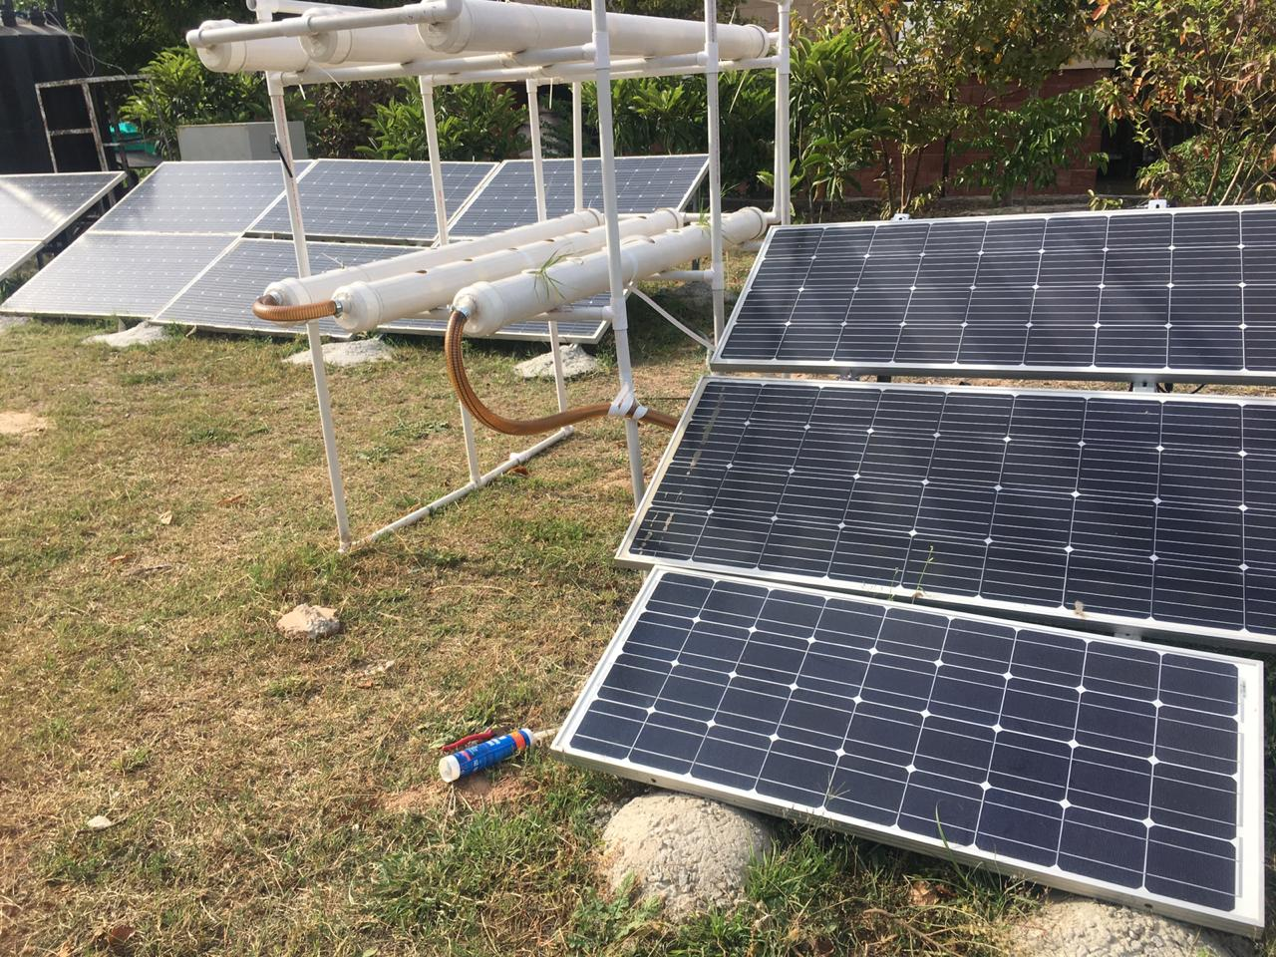

Figure 3.1.4 Functional Structure

The actual implementation of the system can be seen in Figure 3.1.4. The final implementation is of light weight PVC pipes and a solar panel powering the system and storing excess power in the battery.

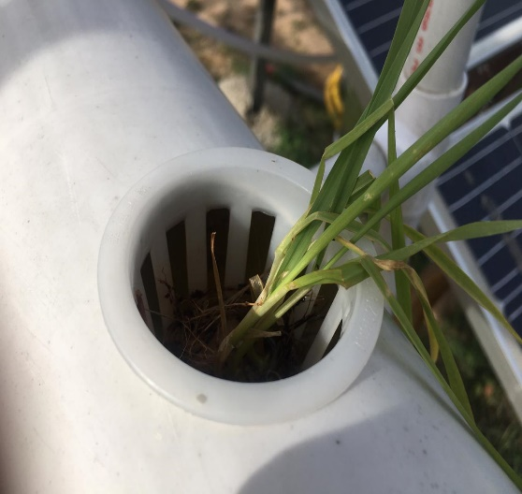

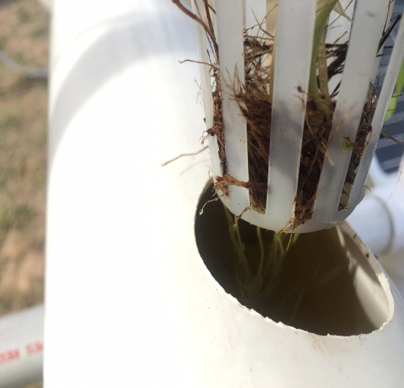

Figures 3.1.5 Crops Grown

A wheat plant growing in the net-pot placed in the system in Figures 3.1.5. The plant has its root submerged in water containing fish waste. This water is pumped from the aquarium using a series dc motor water pump.

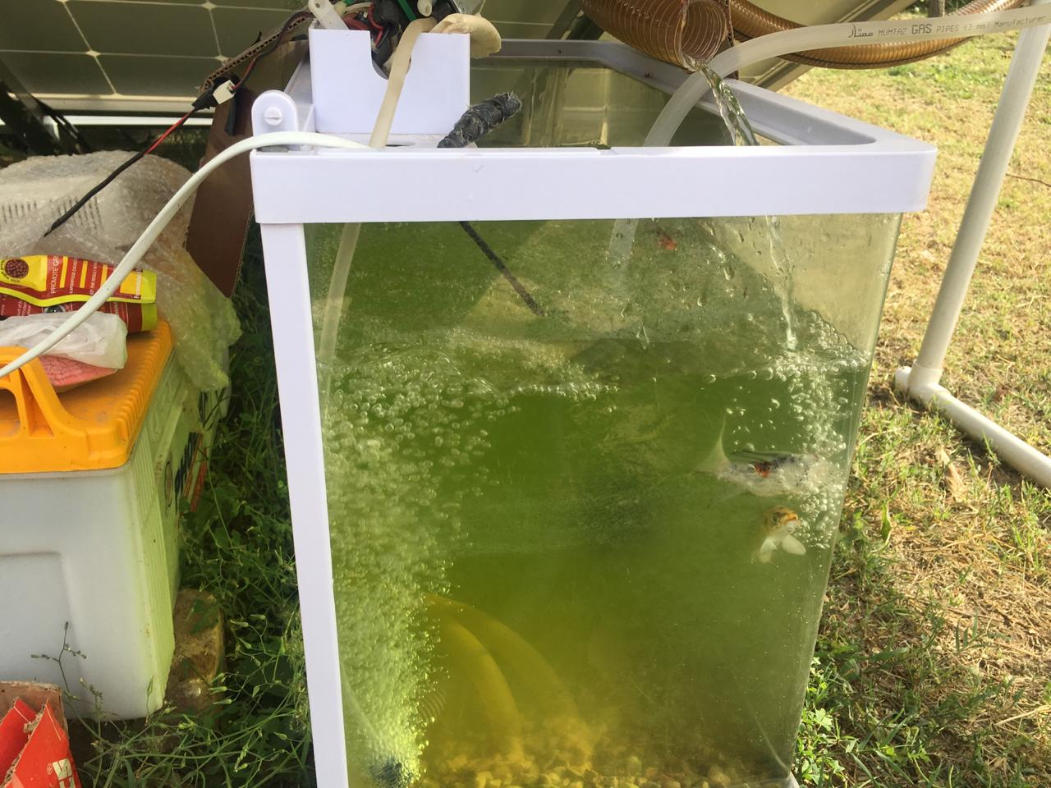

Figure 3.1.6 Aquarium

The aquarium houses a total of 4 fish, which have the potential for growth. Alongside it is the battery. Both of these are placed under the solar panels to protect then from rain and direct sunlight.

### 3.1.3 Sensors:

|  |  |
| --- | --- |
|  |  |

Figure 3.1.7 A&B Sensor 3D Model

The inside and outside view of the sensor mesh can be seen in the 3D model in Figure 3.1.7. The working of sensor mesh can be understood from the flow chart below.

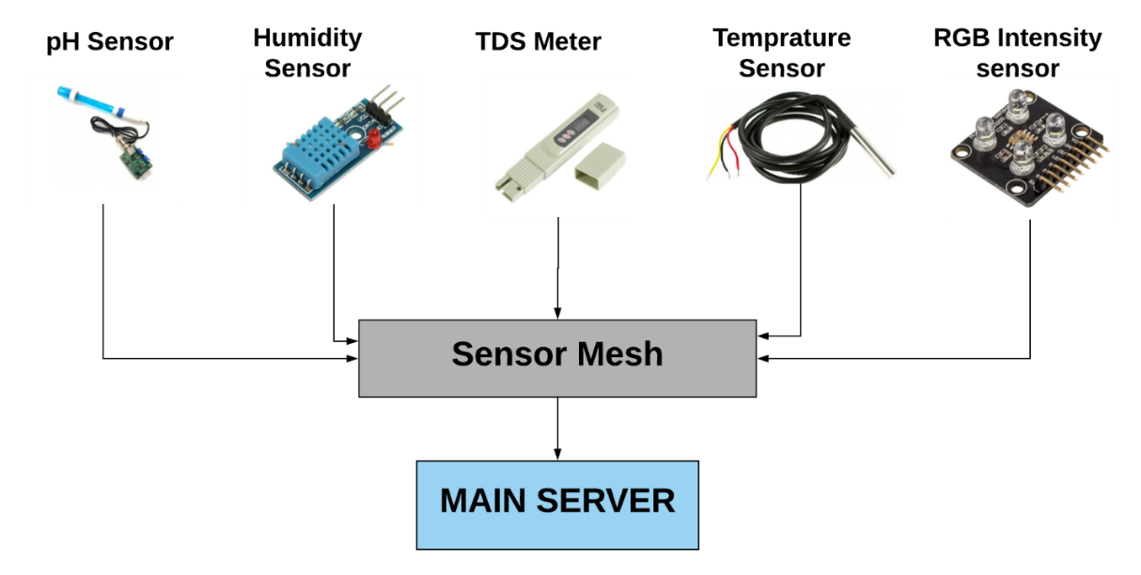

Figure 3.1.8 Sensor Mesh

The sensors are interfaced with the Micro Controller Unit which communicates with the main server using BLE and sends sensor values (of the respective sensors shown below) which are stored on My SQL server and also used in ML algorithm to provide with a prediction.

The table below shows the specific details of the sensors used, i.e. their accuracy, working conditions, limitations etc.

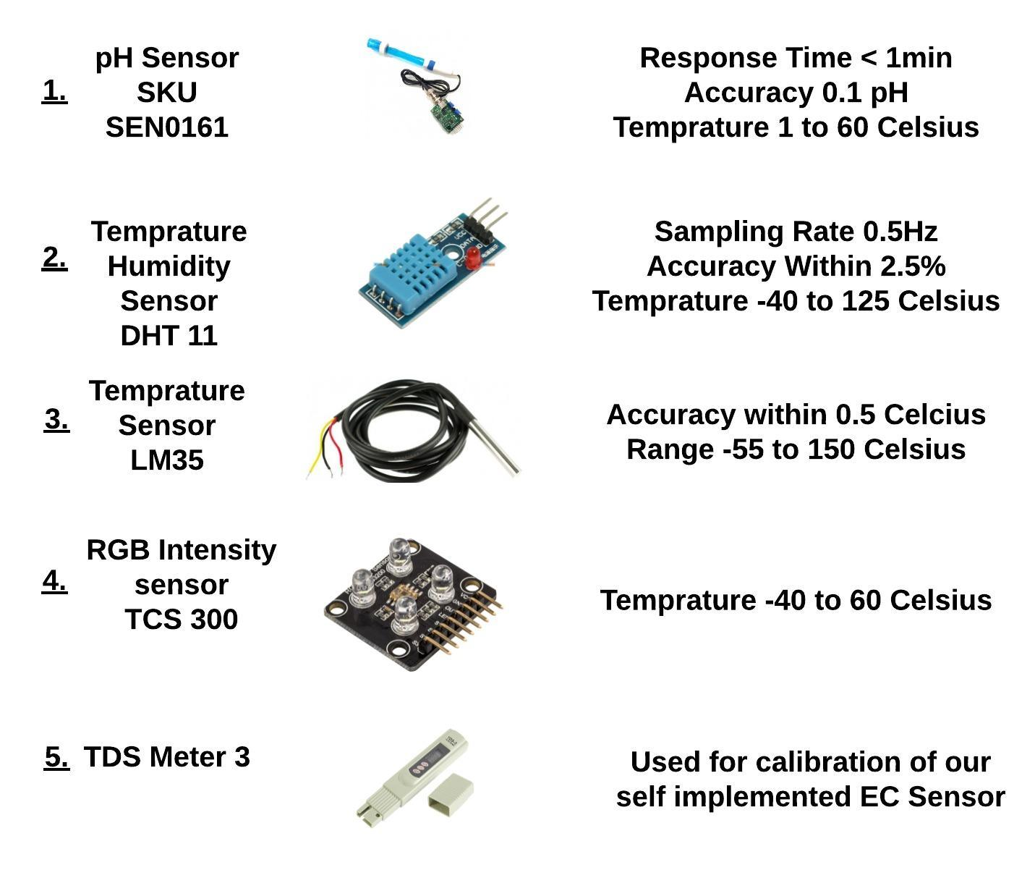

Figure 3.1.9 Sensors

|  |  |  |
| --- | --- | --- |
| Table 3.1 Sensors and Their Uses | | |
|  | **Sensor** | **Use** |
| **1.** | **pH sensor** | Measures pH of water. |
| **2.** | **Air Temperature/ Humidity** | Measures temperature and humidity of Air. |
| **3.** | **Water Temperature sensor** | Measures Temperature of water. |
| **4.** | **RGB Intensity** | Measures light intensity. |
| **5.** | **EC sensor** | Measures Electrical Conductivity, which is used to derive Total Dissolved Solid. |

### 3.1.4 Microcontroller Unit

As already mentioned above these sensors are interfaced with the microcontroller, which operates as a peripheral device. The Micro controller used here is Red bear’s BLE NANO.

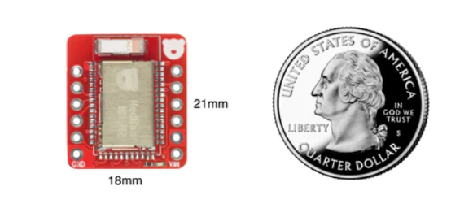

Figure 3.1.10 Readbear BLE Nano v2

It has 6 ADC and 12 Digital I/O. It is BLE enabled and has a flash of 512 KB. It work on input voltages ranging from 3.3V to 13V. The best part is, it is of the size of a penny and can easily be fitted into our sensor mesh.

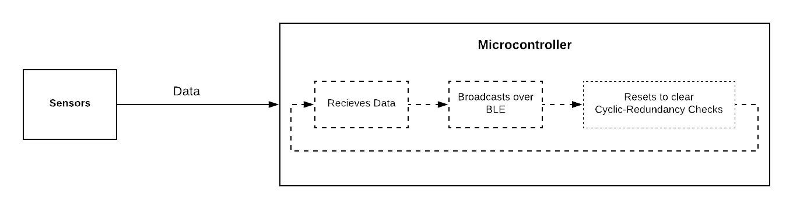

Figure 3.1.11 Data Flow Block Diagram

### 3.1.5 Central Device:

The above mentioned microcontroller will be communicating with the main server (central device) which is based on Raspberry Pi 3b+.

|  |  |
| --- | --- |
|  |  |

Figure 3.1.12 A&B Server Block Diagram & Raspberry Pi 3B+

The main server based on Raspberry Pi uses BLE for communication, it receives data through UUIDs of TX and RX, and uploads data to a MySQL database for storage. It also runs the data through a pre-trained Machine Algorithm.

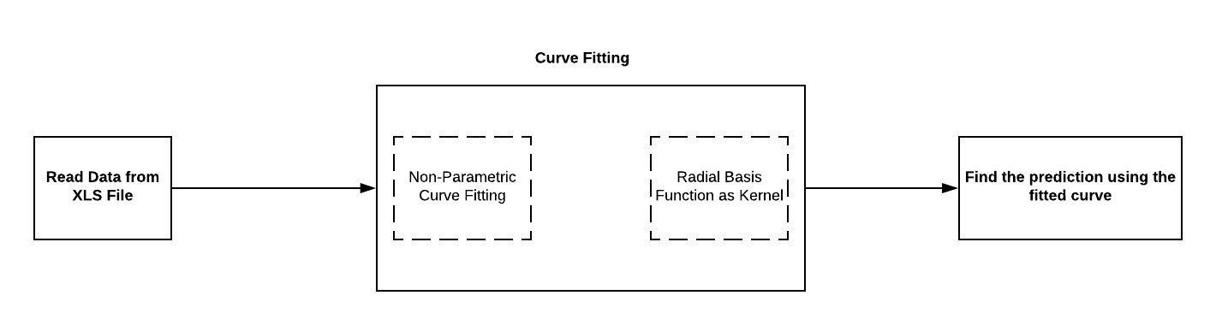

Figure 3.1.13 Curve Fitting Block Diagram

The collected data of the sensors is stored in an XLS file. The data points of each sensor, are extracted and saved in a numpy-array (array like structures in python). Curve fitting is applied to each attribute, i.e. we will have a curve for pH, EC, temp etc.

Now in order to predict, the incoming value will be located in the curve and the values next in the curve will be the predictions. From these predictions the user will determine the appropriate plant for next yield.

### 3.1.6 Solar Panel:

As the system is solar powered, it has a dedicated battery as well as an MPPT Charge controller. The MPPT module used charges the battery as well as powers the system in daylight and the system runs only on battery during the night. The solar panel used in the project is of 80 Watts, which is more than enough to compensate the power requirements of the system.

## 3.2 Justification of method used

The agricultural technique chosen for the system, aquaponics, was due to it having various advantages over other farming techniques. Aquaponics requires an estimate of 90% less water compared to the traditional land based farming techniques. The water decrease is mostly by absorption by plants, or by evaporation. No water is lost to the ground as in traditional farming, where it seeps undergroung unchecked.

The power requirement of aquaponics increases, a lot more than that of land based farming. This is because land based farming mainly uses power to pump water on different periods. While for different techniques for aquaponics, water needs to be circulated continuously, air pumps are needed to keep the fish from suffocating; and for indoor setups, lamps are used to compensate for the deficiency of sunlight. This increased power requirement is solved by using solar panels, and storing the excess electrical energy produced in batteries, for later use at night.

Hydoponics and aquaponics are essentially the same, with the exception of the use of fish. Hydroponics is a comparatively easier farming technique, which uses fertilizer instead of fish waste. The two techniques already do not require the use of pesticides as in land based farming; with the addition of fish waste, the need to add chemical fertilizers – as in hydroponics – is eliminated. Making aquaponics suited for the growing awareness and demand for organics crops in Pakistan.

Another farming technique, aeroponics, was not considered suitable for the system, as it has an increased demand for electrical power. Verses, aquaponics, water is required to be circulated at increased pressures to create a water mist for use in aeroponics. Furthermore water lost due to the mist is more than that in hydroponics and aquaponics, but is still less than that of land based farming.

The technique of aquaponics used above is known as NFT (Nutrient Film Technique). Nutrient Film Technique is a commonly used hydroponic method, but is not as common in aquaponics systems. In NFT systems, nutrient rich water is pumped down small enclosed gutters, the water flowing down the gutter is only a very thin film. Plants sit in small plastic cups allowing their roots to access the water and absorb the nutrients. NFT is only really suitable for certain types of plants, generally leafy green vegetables, and larger plants will have root systems that are too big and invasive, or they become too heavy for the lightweight growing gutters.

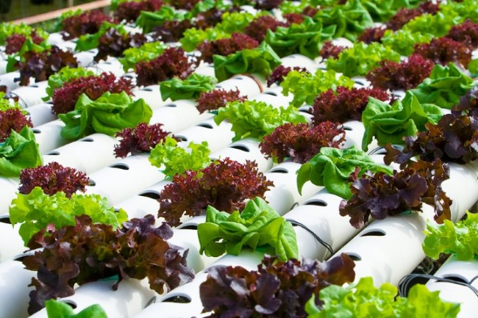

Figure 3.2.1 NFT example

In all other forms of production, there is a conflict between the supply of these requirements, since excessive or deficient amounts of one results in an imbalance of one or both of the others. NFT, because of its design, provides a system wherein all three requirements for healthy plant growth can be met at the same time, provided that the simple concept of NFT is always remembered and practiced. The result of these advantages is that higher yields of high-quality produce are obtained over an extended period of cropping. A downside of NFT is that it has very little buffering against interruptions in the flow, e.g., power outages, but, overall, it is one of the more productive techniques.

## 3.3 Justification of design tools

In the system described above, one may ask many questions regarding the choices made in selection of the design tools.

Let’s start off with the structure, it is made up of PVC to keep it light and sturdy, thus making it compatible for urban use. The users will be able to deploy the system on rooftops and terraces of apartments or their houses without the risk of extra weight. The system is solar powered, in countries like Pakistan load-shedding of electricity is a huge problem, hence the system is kept solar powered to diminish the reliance on main supply.

The small size of the chosen Micro-controller, makes it easy to be deployed in any system of any size and the nature of the sensors used, gives the user autonomy to use the sensor mesh system in aquaponics or hydroponics system. The machine learning algorithm is used to predict the future state of the system, thus giving user an insight into the future.

## 3.4 Basic theoretical information about each component

### 3.4.1 BLE Communication:

BLE or Bluetooth Low Energy, is a wireless personal area network technology, intended to provide considerably reduced power consumption and cost as compared to Bluetooth Classic, while maintaining a similar communication range.

### 3.4.2 GATT:

GATT also known as General Attribute Profile, defines the way two BLE devices transfer data, between each other. It makes use of ATT, which is a generic data protocol. ATT stores Services, Characteristics and related data in a look-up table, using 16 bit IDs.

|  |  |
| --- | --- |
| Table 3.4.1 Data stored in ATT | |
| **Characteristic** | A characteristic contains a single value and 0-n descriptors that describe the characteristic's value. A characteristic can be thought of as a type, analogous to a class. |
| **Descriptor** | Descriptors are defined attributes that describe a characteristic value. For example, a descriptor might specify a human-readable description, an acceptable range for a characteristic's value, or a unit of measure that is specific to a characteristic's value. |
| **Service** | A service is a collection of characteristics. For example, you could have a service called "Heart Rate Monitor" that includes characteristics such as "heart rate measurement." |

### 3.4.3 Connected Network Topology:

Initially the device in the central role, looks for advertisement, and the device in the central role makes the advertisement.

Once a connection is made between two devices (or more i.e. peripherals and central device), communication can take place in both directions, which is different than the one-way broadcasting approach using only advertising data and GAP.

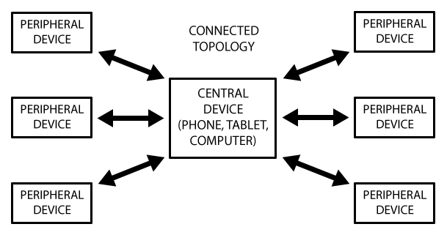

Figure 3.4.1 Topology of BLE Communication

### 3.4.4 GATT Transactions:

The peripheral is known as GATT server, and the central is known as GATT Client. The client sends request to the server and the server sends response, this happens in one connection interval.

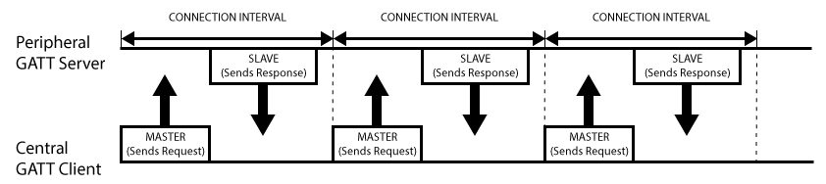

Figure 3.4.2 GATT Transaction

Let us discuss a little more about Profile, Service and Characteristics in detail.

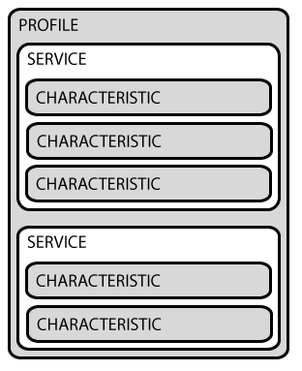

Figure 3.4.3 Illustrations of Profiles, services and characteristics

A Profile doesn't actually exist on the BLE peripheral itself, it's simple a pre-defined collection of Services, Services are used to break data up into logic entities, and contain specific chunks of data called characteristics, The lowest level concept in GATT transactions is the Characteristic, which encapsulates a single data point. Each Characteristic distinguishes itself via a pre-defined 16-bit or 128-bit UUID (Universally unique Identity).

### 3.4.5 Curve Fitting (Support Vector Regression):

It is a process of constructing a curve or fitting a mathematical function, on a series of data points.

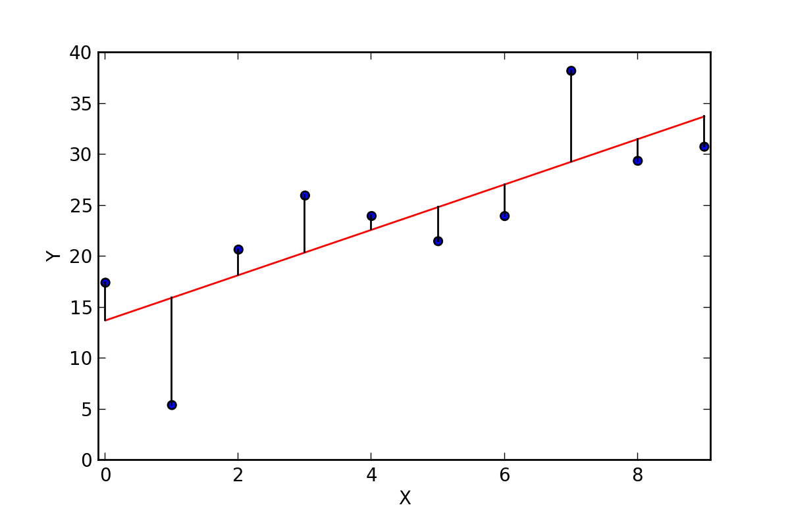

Figure 3.4.4 Linear curve fitting on random data points

In this project we are using a much more sophisticated approach known as Support Vector Regression.

### 3.4.6 Support Vector Machines and Support Vector Regression

Support vector regression (SVR), is inspired from Support Vector Machines (SVM) which are maximum margin classifiers. SVM is discriminative classifier which classifies using a hyper plane as shown below.

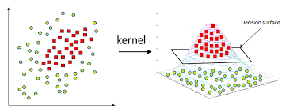

Figure 3.4.5 Use of hyper plane by SVM

As we can see above that a problem which would conventionally be solved using a non-linear decision surface is solved by a hyper plane, this takes our problem to a higher dimension feature space. Now one may wonder that higher dimensions can cause the curse of dimensionality but kernel functions are used to solve the complex computations involved in such situations.

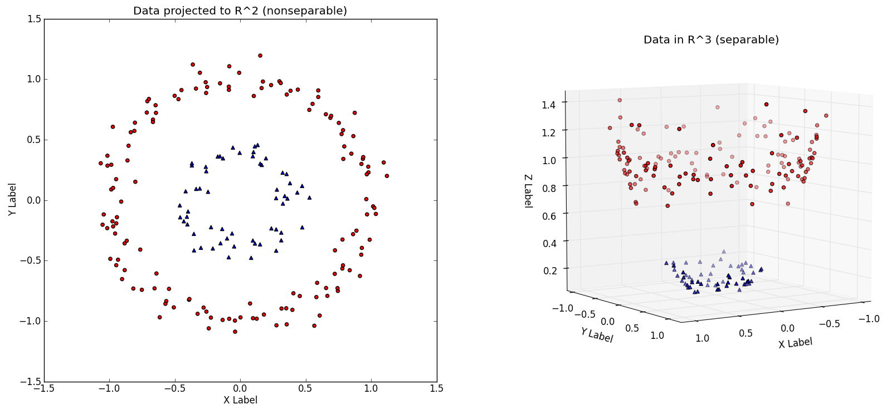

Figure 3.4.6 A problem in R2 is projected to R3 to get a linear decision boundary

In the above plots we can see, the use of increase in dimensionality to solve a classifying problem, this higher dimension involves more complex computation. Kernel trick is the technique used to skip the complexity and keep the computations fast.

SVR is a bit different from SVM, SVR is regression not classification. SVR is also different from simple regression, in simple regression we try to minimize the error rate. While in SVR we try to fit the error within a certain threshold.

|  |  |
| --- | --- |
| Table 3.4.2 Some basic terms used above and later on in this discussion | |
| **Kernel** | It is the function which is used to map a lower dimensional data into a higher dimensional data. |
| **Hyper Plane** | In SVM this is basically the separation line between the data classes. Although in SVR we are going to define it as the line that will help us predict the continuous value or target value. |
| **Boundary Line** | The support vectors can be on the Boundary lines or outside it. This boundary line separates the two classes. In SVR the concept is same. |
| **Support Vectors** | This are the data points which are closest to the boundary. The distance of the points is minimum or least. |

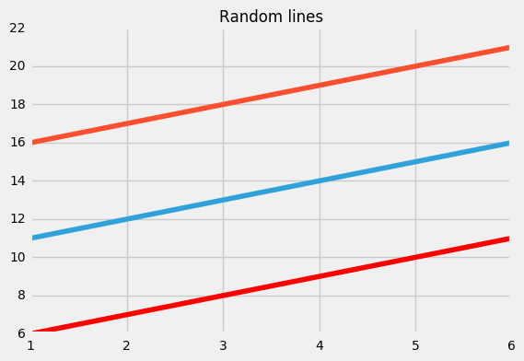

Figure 3.4.7 Red Lines are boundary line while Blue line is hyper plane.

Let’s assume the boundary lines above (red) are at a distance ‘*e’* from the hyper plane. Which means there distances will be ‘+e and –e’.

Assume hyper plane is a straight line going through y-axis, then we may say, equation of hyper-lane is,

***Wx+b=0***

Thus the two boundary line will have following equations,

***Wx+b=+e;***

***Wx+b=-e;***

Thus coming in terms with the fact that for any linear hyper plane the equation that satisfy our SVR is:

***e≤y-Wx-b≤+e***

Stating the fact that, y=Wx+b.

What we are trying to do here is basically trying to decide a decision boundary at ‘e’ distance from the original hyper plane such that data points closest to the hyper plane or the support vectors are within that boundary line.

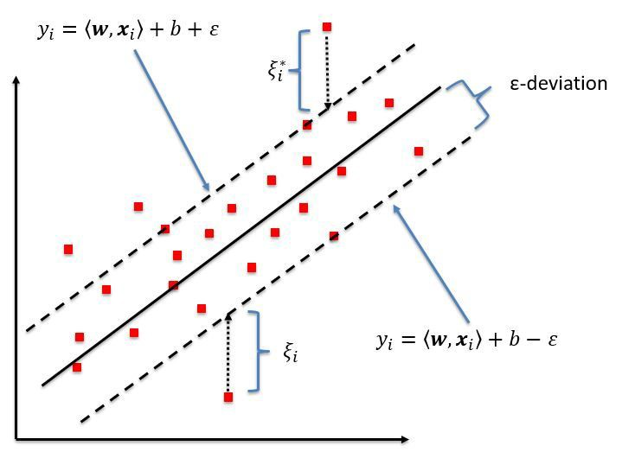

Figure 3.4.8 Linear SVR explanation

Thus the decision boundary is our Margin of tolerance that is we are going to take only those points who are within this boundary, or in simple terms that we are going to take only those points which have least error rate. Thus giving us a better fitting model.

In non-linear SVR, the kernel functions transform the data into a higher dimensional feature space to make it possible to perform the linear separation.

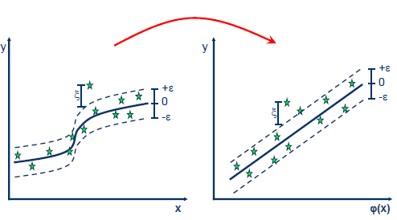

Figure 3.4.9 Converting non-linear regression to linear regression

### 3.4.7 Maximum Power Point Tracking (MPPT)

There is a limited period of time available during which the sunlight if of high enough intensity to be utilized for electricity production. Furthermore the solar panels used are limited and provide limited power (W), when current is drawn. To extract the maximum possible power an MPPT module is used.

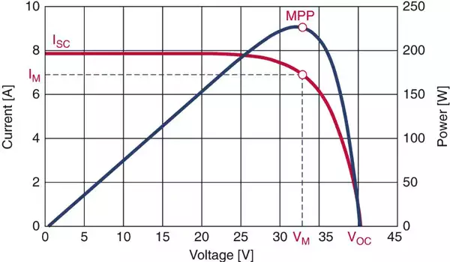

Figure 3.4.10 Maximum Power Point

With an increased amount of current, the voltage level of the panel drops. The module runs on an algorithm which varies the current and voltage drawn in an effort to find maximum power point on the curve. At that point the module maintains the power drawn. Thus delivering the maximum power available.

The algorithms used in the module can be Perturbation and Observation (P&O), Ripple Correlation and Incremental Conductance (IncCond). Among these, IncCond is an effective algorithm that has the fastest rate of extraction, and the least ripple at steady state. Making it a better choice for the module.

In simple terms, IncCond works by taking the difference, of the voltage and current measured with their past values. Depending on its value, it decides if to draw more or less current.

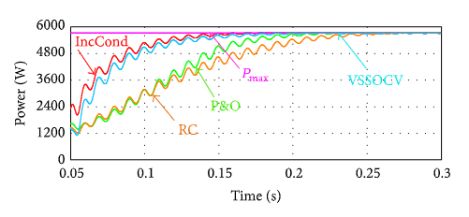

Figure 3.4.11 MPPT Algorithms during start-up

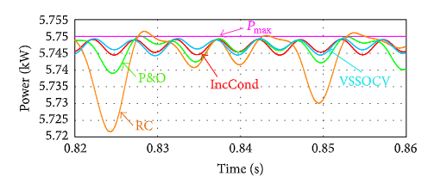

Figure 3.4.12 MPPT Algorithms at steady state

# *Chapter 4*

# Implementation and Results

## 4.1 Implementation

**In the implemented system**, as explained earlier a BLE peripheral device communicates with the Central device. The Peripheral device used is a Red Bear BLE Nano V2 and Central device is Raspberry Pi 3b+. The data of EC (Electrical Conductivity), pH and Temperature is sent from peripheral to the central device from where the data is stored on SQL server and also used to get a prediction on the central device where SVR algorithms are used.

The snapshots of working system are already shared in chapter 3, i.e. (Fig 3.1.2 to Fig 3.1.7). We can observe the system where the water pump and air pump are running on solar panels, and the water from aqua-culture is pumped to PVC structure. The sensor mesh in Fig. 3.1.7 contains the peripheral device, 2 batteries, connecting PCB and sensors. The 2 batteries are 3.7V and 400mAh each.

In the implemented system, user gets smart monitoring, and viable predictions from the system about the current and next yield. During the implementation a number of problems were encountered.

**A number of problems were faced during this project** and all of them helped us in learning new techniques. Since RBL NANO V2, uses Arduino IDE for coding purposes it makes it easier for user to access Analogue and Digital Pins, but at the same time many libraries which are compatible with Arduino are not supported by Nordic, since Arduino is based on Atmel Architecture and Nordic has a different architecture. Due to this problem, we went through the already available libraries, understood their working and replicated the algorithms used there, in our own code, hence this enabled us to get an insight into how MCU takes and processes raw values from sensors into useful reading.

Major problems were faced during establishing communication between central and peripheral devices, since Red Bear Nano is a new MCU, and there is very less support available online, so one can get the general idea that there was very less material available for communication between RBL NANO and Pi 3b+. Fortunately there is an IOS application that communicated with RBL NANO example *BLE_HRM,* we read its source code, and sent the same commands from central device for handshake and it worked.

The structure design and water-proofing took a lot of time, and many water leakages in the structure were dealt at a later stage which increased complications because plants were already placed in the system.

## 4.2 Results

We can see the results of communication between peripheral device and central device, the central device sends request to the GATT Server (i.e. Peripheral Device). The peripheral device recognizes the request and starts communication.

The values sent first are in hexadecimal, they are then converted to decimal and are displayed in the Linux console below. The solution used in this case a standard solution of pH equivalent to 3.

In the figure below we can observe that values are sent 5 times and first 3 values are pH, next 3 are temperature, and last is EC (Electrical Conductivity). The average of all the received values is used as a final result.

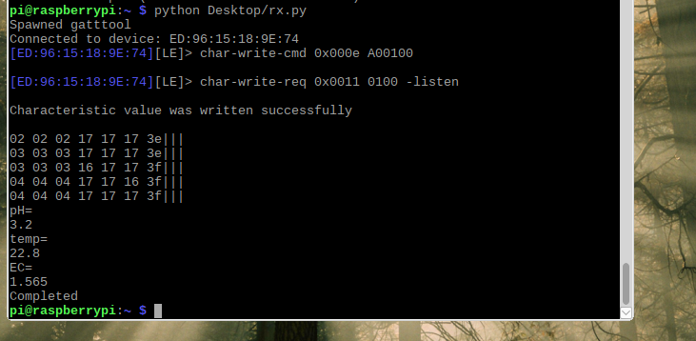

Figure 4.1 Results in Raspberry Pi

The results of the machine learning algorithm are shown below. In these results, the value of EC/ TDS were measured manually and used to get a prediction for the system. The data-set used here was of 30 days, the blue line shows the fitted model and the red one shows the prediction made for the next day, based on the history of the data.

The regression technique used here is SVR (Support Vector Regression) and it is inspired from SVM, and explained in very detail in the section 3.4.6.

The curve is obtained using SVR, and the algorithm tries to find the nearest value to the incoming value, and then outputs at the next value. This technique gives good results on small datasets and due to the nature of our data (which is already in small quantity) this technique provides good enough results.

The incoming value here was 308ppm (TDS is derived reading from EC, EC = TDS/700), the system predicted the value on the next day to be 310. In case of large data sets Neural Networks can be used to obtain better results.

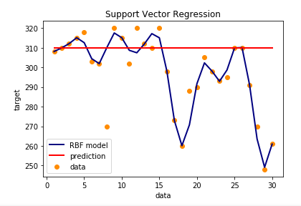

Figure 4.2 SVM Results

# *Chapter 5*

# Conclusion and Recommendation

## 5.1 Conclusion

At the end of this project we can conclude that the technique of aquaponics is a viable alternative to the traditional farming techniques in terms of water and land usage and running costs. Although in an agricultural country like Pakistan, where agricultural land is in abundance, but the shortage of water is a big issue and it needs to be catered for and aquaponics is the way to solve this issue.

The main target of this project was to bring aquaponics to urban areas, where people have a busy life, hence the need of automation of this technique is extremely important. This project provides smart suggestions and smart monitoring system to the users and makes it easier for them to grow their organic food in their homes and enjoy cheap and healthy food.

From the practical implementation of this technique we can conclude that this technique requires a pre-matured aqua-culture, and pre-matured plants of suitable sizes. So that they can survive in sunlight and fishes can survive the temperature and pH changes in water, resulting from changing in the environment.

At the end we conclude that this technique is one of the best counter-measure against the threat of global hunger and famine in African countries and this technique should be adopted at an industrial scale to reap benefits at a national and international level.

## 5.2 Recommendation

Although the proposed system is smart and stand-alone, it can still be improved in multiple areas by utilizing the useful recommendation provide in this section below.

The user is limited to using the Raspberry Pi to check the values and states of the plants. This can easily be made more friendly and effective by connecting the Raspberry Pi to the internet. An online server will be required to store each value, separately, for every user. The user can then access the graphs, and the current state of the system through the android application by using his/her registered username and password.

Furthermore the user can be able to control the system from the application, once connected to the net. Exhausts can be used to control the air flow through the system, and provide the crops with enough amount of carbon dioxide and oxygen, as required for their growth. Water sprinklers can be used in front of the exhausts, which will help to increase the humidity and drop the temperature for optimum plant growth.

For days with low sunlight hours, or systems placed indoors; incandescent lamps with high light intensity can be used to compensate the light deficiency. However more solar panels will be required to provide the lamps with high amounts of power. Red and Blue LEDs with high light intensity and a ratio of 3 red to 1 blue will be more efficient. The plants, however, will still require at least 8 hours of rest in the dark, to process the carbohydrates produced.

Live feed of the plants can also help in improving the system. The image feed can be used in image processing techniques to check the plants for yellow spots – that indicate deficiency on nutrients –, wilting etc. This can help identify is the plants require more care, or are ready for harvest.

The crops should not be added in the system, until the aquaculture is pre-mature and the fish are excreting enough nutrients. Otherwise the plants will not properly adapt to the system and their growth will be inhibited.

# References

## Journals

* Barbosa, Guilherme Lages (June 2015); “Comparison of Land, Water, and Energy Requirements of Lettuce Grown Using Hydroponic vs. Conventional Agricultural Methods”

International Journal of Environmental Research and Public Health;

DOI: 10.3390/ijerph120606879

* Hlaili, Manel (2016); “Comparison of Different MPPT Algorithms with a Proposed One Using a Power Estimator for Grid Connected PV Systems”

International Journal of Photoenergy; Volume 2016; Article ID 1728398

* Mamat, Nawwar Zawani (October, 2016); “The Production of Catfish and Vegetables in an Aquaponic System”

DOI: 10.4172/2150-3508.1000181

* Murad, Sohiful Anuar Zainol (September 2017); “Design of aquaponics water monitoring system using Arduino microcontroller”

AIP Conference Proceedings; DOI: 10.1063/1.5002442

* Wang, Dan (2015), “Design of A Smart Monitoring and Control System for Aquaponics Based on OpenWrt”

ICIMM 2015

## Books

* Kenyon, Stewart (1979)’; “Hydroponics for the Home Gardener”
* Roberto, Keith (August 2003); “How to Hydroponics 4th Edition”

Publisher: Futuregarden

## Internet

* Bhattacharyya, Indresh; “Support Vector Regression Or SVR”

<https://medium.com/coinmonks/support-vector-regression-or-svr-8eb3acf6d0ff>

* Bluetooth low energy overview

<https://developer.android.com/guide/topics/connectivity/bluetooth-le>

* Dr. Lennard, Wilson; “AQUAPONIC GARDENING RULES OF THUMB”

<https://www.theaquaponicsource.com/rules-of-thumb/>

* GATT

<https://learn.adafruit.com/introduction-to-bluetooth-low-energy/gatt>

* Global Hydroponics Market is Projected to Grow at a CAGR over 6.39% post 2022

<https://www.prnewswire.com/news-releases/global-hydroponics-market-is-projected-to-grow-at-a-cagr-over-639-post-2022-300453146.html>

* Hydroponics Market - Global Industry Analysis, Size, Share, Growth, Trends, and Forecast 2017 – 2025

<https://www.transparencymarketresearch.com/hydroponics-market.html>

* Plant PH/EC/PPM

<https://hydroponic.co.za/hydroponics-quickstart/plant-phecppm/>

* Residuals for Linear Regression

<https://commons.wikimedia.org/wiki/File:Residuals_for_Linear_Regression_Fit.png>

* Support Vector Machine - Regression (SVR)

<https://www.saedsayad.com/support_vector_machine_reg.htm>